A

Project Report

On

***Online Paint***

Submitted by

***Rishabdev Panchal [2205103140012]***

***Kajal Dubey [2205103140007]***

***Priyanshi Patel [2205103120030]***

as

Partial fulfilment of Semester V

of Integrated Masters of Computer Applications

for A.Y. 2024-2025

Under the Guidance of

Internal Guide: ***Prof. Shikha Bansal***

External Guide: ***Prof. Shikha Bansal***

Submitted To

Parul Institute of Computer Application,

Faculty of IT & Computer Science

Parul University



**Acknowledgement**

*The success and final outcome of this project required a lot of guidance and assistance from many people and we are extremely privileged to have got this all along the completion of our project. All that we have done is only due to such supervision and assistance and we would not forget to thank them.*

*I respect and thank Dr. Priya Swaminarayan, Dean, FITCS for providing us an opportunity to do the project work in BCA and giving us all support and guidance which made us complete the project duly. We are extremely thankful to Mam for providing her support and guidance, although she had a busy schedule managing the academic affairs.*

*We would not forget to remember Dr. Hina Chokshi, HOD, BCA department for her encouragement and more over for her timely support and guidance till the completion of our project work.*

*We owe our deep gratitude to our project guide* ***Prof. Shikha Bansal****, who took keen interest on our project work and guided us all along, till the completion of our project work by providing all the necessary information for developing a good system.*

*I am thankful to and fortunate enough to get constant encouragement, support and guidance from our Parents, all Teaching staff of the IMCA Department which helped us in successfully completing our project work. Also, we would like to extend our sincere esteems to all staff in the laboratory for their timely support.*

***Rishabdev Panchal [2205103140012]***

***Kajal Dubey [2205103140007]***

***Priyanshi Patel [2205103120030]***



**PARUL INSTITUTE OF COMPUTER APPLICATION**

**CERTIFICATE**

This is to certify that ***Rishabdev Panchal*, *Kajal Dubey*, *Priyanshi Patel*** the students of Parul Institute of Computer Application, has/have satisfactorily completed the project entitled ***“Online Paint”*** as a part of course curriculum in IMCA semester- V for the academic year 2024-2025 under guidance of ***Prof. Shikha Bansal***.

Enrolment Number: 2205103140012

Enrolment Number: 2205103140007

Enrolment Number: 2205103120030

|  |  |  |
| --- | --- | --- |
| **Quality of work** | **Grade** | **Sign of Internal guide** |
| **Poor / Average / Good /Excellent** | **B / B+ / A / A+** |  |

Date of submission:

HOD, Principal,

Dr. Hina Chokshi Dr. Priya Swaminarayan

**INDEX**

|  |  |
| --- | --- |
| **Content** | **Page No.** |
| 1.     Introduction to Project System | 01 |
| 2.     System Requirement Specification | 02 |
| 2.1  Introduction to SRS | 02 |
| 2.2  Hardware Requirement | 02 |
| 2.3  Software Requirement | 02 |
| 2.4  System Users | 03 |
| 2.5  Description of User Role | 03 |
| 2.6   System Modules | 03 |
| 2.7  Description of Modules | 03 |
| 2.8  Timeline Chart | 04 |
| 3.     System Flow Diagram | 05 |
| 4.     Data Flow Diagram (All Levels of DFDs) | 06 |
| 4.1 Level 0 Data Flow Diagram | 06 |
| 4.2 Level 1 Data Flow Diagram | 07 |
| 4.3 Level 2 Data Flow Diagram | 08 |
| 5.     Use Case Diagram | 09 |
| 6.     Class Diagram | 10 |
| 7.     Screenshots of Development Phase - 1 | 11 |
| 8.     Screenshots of Development Phase - 2 | 12 |
| 9.  Screenshots of Development Phase - 3 | 13 |
| 10.  Conclusion | 14 |
| 11.  Future Enhancement | 15 |
| 12.  References | 16 |

**ABSTRACT**

Online Paint is a lightweight, web-based drawing application designed to provide users with an intuitive platform for creating simple diagrams, sketches, and illustrations directly in their web browser. Developed using React and HTML5 Canvas, this project delivers a smooth and responsive user experience while maintaining ease of use for both beginners and more advanced users. The application allows users to express their creativity through a range of drawing tools, including freehand drawing, basic shapes such as rectangles, circles, and lines, as well as an eraser and fill tool for enhancing their designs.

Key features of Online Paint include a flexible color selection palette, adjustable pen size, and essential functions such as undo and redo. Users can also save their drawings as PNG images, allowing them to easily share or store their work. The project showcases the use of modern web development techniques, particularly highlighting the seamless integration of React with HTML5 Canvas to manage dynamic, canvas-based graphics.

Online Paint exemplifies how a simple yet functional drawing tool can be built using contemporary technologies, offering a practical solution for web-based graphics creation. It also demonstrates the potential of React for handling interactive user interfaces, making it a valuable learning resource for developers interested in web-based drawing applications.

**Chapter 1  
Introduction to my Project**

* Online Paint is a lightweight web-based drawing tool for creating sketches, diagrams, and illustrations.
* Built using React and HTML5 Canvas, it replicates traditional drawing tool features.
* Key features include freehand drawing, shapes, color selection, undo/redo, and saving as PNG.
* The app ensures a seamless experience for both beginners and advanced users.
* It demonstrates modern web development techniques like component-based architecture and state management.
* The modular design allows easy maintenance and future upgrades.
* Online Paint showcases the integration of React with HTML5 Canvas for web-based graphics.
* It serves as a platform for exploring advanced web-based graphical capabilities.

**Chapter 2**

**System Requirement Specification**

**2.1 Introduction to SRS**

**2.1.1 What is SRS?**

A software requirements specification (SRS) is a description of a software system to be developed. It lays out functional and nonfunctional requirements and may include a set of use cases that describe user interactions that the software must provide.

**2.1.2 Need of SRS**

In order to fully understand one’s project, it is very important that they come up with a SRS listing out their requirements, how are they going to meet it and how will they complete the project. It helps the team to save upon their time as they are able to comprehend how are going to go about the project. Doing this also enables the team to find out about the limitations and risks early on.

**2.2 Hardware Requirement**

|  |  |
| --- | --- |
| **Hardware Component** | **Specification** |
| Processor | Dual-core processor (2.0 GHz or higher) |
| RAM | 4 GB or more |
| Hard Disk | At least 200 MB of free space (for browser cache and temporary files) |
| Device | Desktop, Laptop, or Tablet with modern web browser support |

**2.3 Software Requirement**

|  |  |
| --- | --- |
| **Name of component** | **Specification** |
| Operating System | Windows, macOS, or Linux (any OS that supports modern browsers) |
| Software Development Kit | Node.js (for running and building the React app) |
| Programming language | JavaScript (React framework), HTML5, CSS |
| Code Editor | Visual Studio Code, Sublime Text, or any other text editor suitable for web development |

**2.4 System Users & Modules**

2.4.1Default User

**2.5 Description of Users & Modules**

**2.5.1 Default User**

The default user of Online Paint is anyone needing a simple web-based tool for quick sketches, diagrams, or illustrations. The user requires basic web-browsing skills and can access the app on a desktop, laptop, or tablet.

**2.6 System Features**

2.6.1 Supports multiple drawing tools

2.6.2 Allows color selection and adjustable pen sizes

2.6.3 Undo, redo, and clear canvas functionality

2.6.4 Saving drawings

**2.7 Description of Features**

**2.7.1 Supports multiple drawing tools**

Online Paint offers essential tools like freehand, rectangle, circle, line, and eraser to create a variety of sketches and shapes. These tools provide flexibility for users to express their ideas through different drawing styles.

**2.7.2 Allows color selection and adjustable pen sizes**

Users can customize their drawings by choosing from a range of colors and adjusting the pen size to fit their needs. This feature helps in creating more personalized and detailed artwork.

**2.7.3 Undo, redo, and clear canvas functionality**

The app supports undo and redo options to easily correct mistakes, and a clear canvas feature for starting fresh. These tools enhance the drawing experience by allowing quick edits without hassle.

**2.7.4 Saving drawings**

Users can save their creations as PNG images, allowing them to download and share their artwork. This ensures that their work can be preserved for future use or modifications.

**2.8 Timeline Chart**

|  |  |  |  |  |  |  |  |
| --- | --- | --- | --- | --- | --- | --- | --- |
| **Development phase** | ***75 Days*** | | | | | | **Duration**  **N**  **(days)** |
| 0to10 days | 11to20  days | 21to30 days | 31to40 days | 41to50 days | 51to75  days |
| **Requirement**  **Gathering** |  |  |  |  |  |  | 07 |
| **Analysis** |  |  |  |  |  |  | 09 |
| **Design** |  |  |  |  |  |  | 10 |
| **Development Phase 1** |  |  |  |  |  |  | 13 |
| **Development Phase 2** |  |  |  |  |  |  | 13 |
| **Development Phase 3** |  |  |  |  |  |  | 13 |
| **Documentation** |  |  |  |  |  |  | 10 |
| **Total time**  **(Days)** |  | | | | | | **75** |

Figure 2.8Timeline chart of Online Paint

**Chapter 3  
System Flow Diagram**

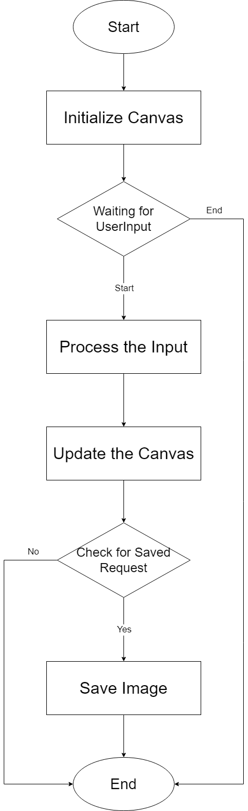

Figure 3.1 System Flow Diagram for Online Paint **Chapter 4  
Data Flow Diagrams**

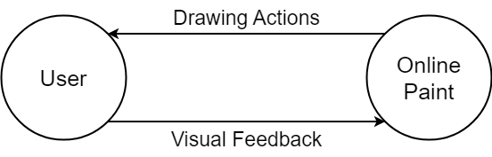 **4.1 DFD Level 0**Figure 4.1 Data Flow Diagram (Level 0) for Online Paint

**4.2 DFD Level 1**

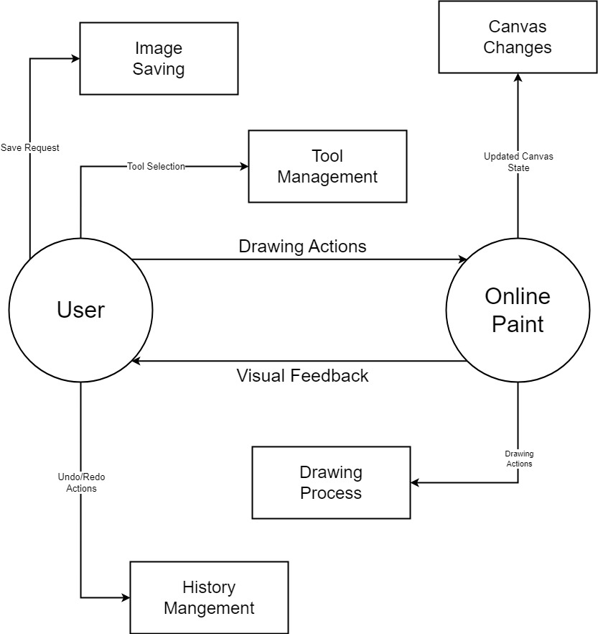

Figure 4.2 Data Flow Diagram (Level 1) for Online Paint

**4.3 DFD Level 2**

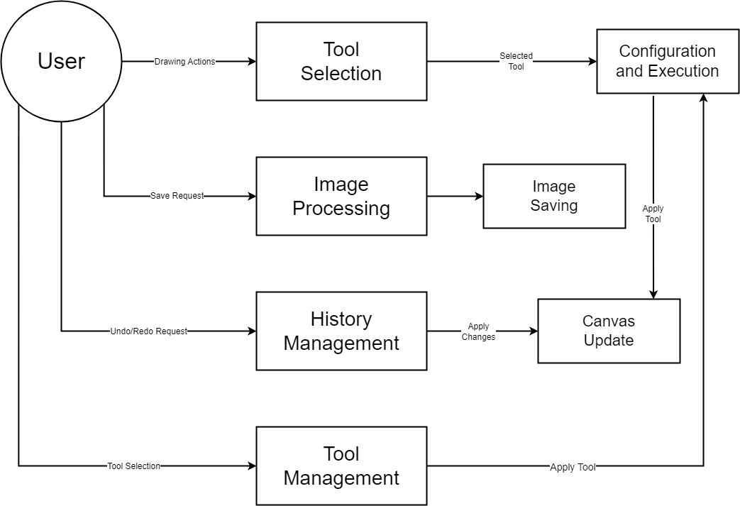

4.1 Data Flow Diagram (Level 2) for Online Paint

**Chapter 5  
Use Case Diagram**

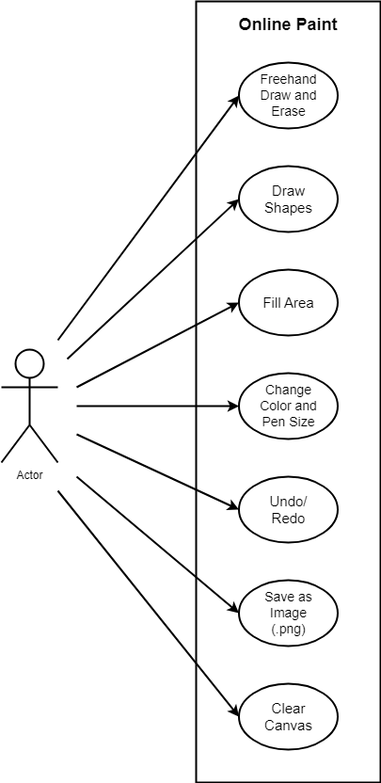

Figure 5.1 Use Case Diagram for Online Paint

**Chapter 6**

**Class Diagram**

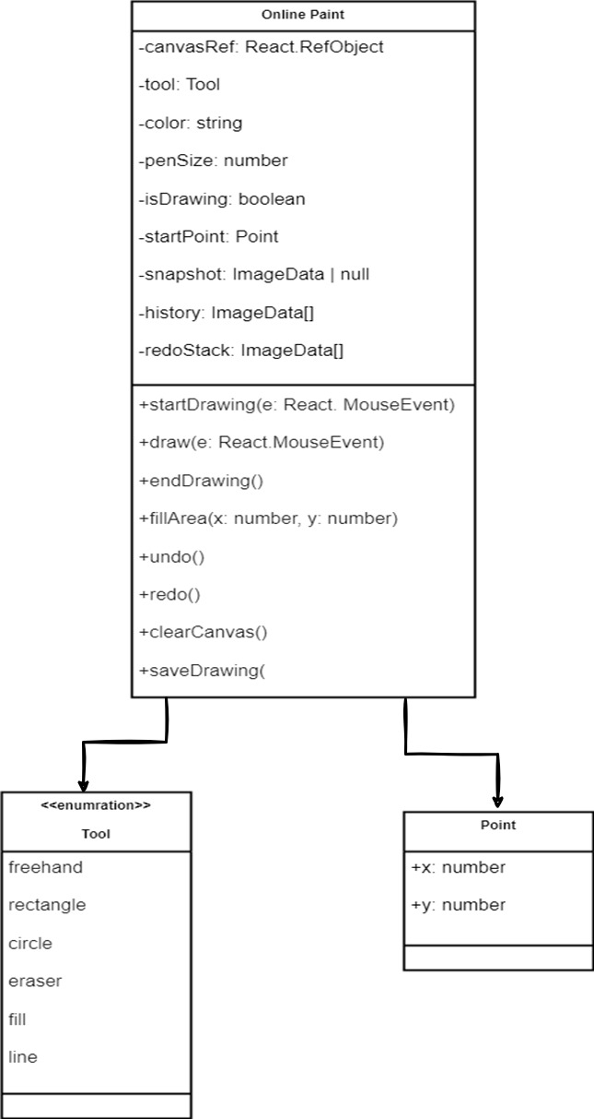

Figure 6.1 Class Diagram for Online Paint

**Chapter 7  
Screenshots of Development Phase I**

7.1 Online Paint Phase I:

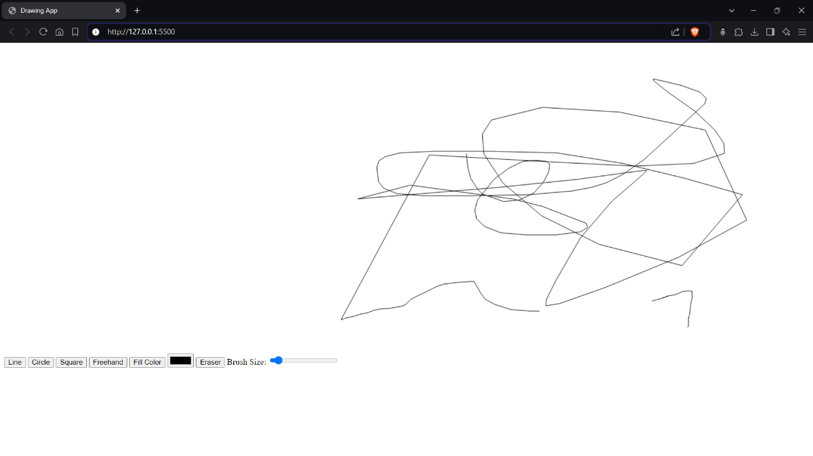  
  
  
  
  
  
  
  
  
  
Figure 7.1 Phase I of Online Paint

7.2 Code for Online Paint Phase I:

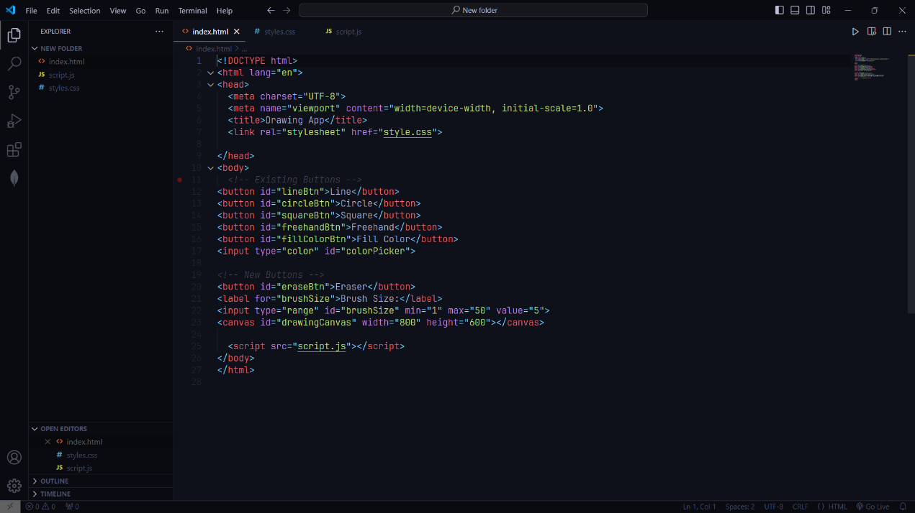

Figure 7.2 Code for Phase I of Online Paint

**Chapter 8  
Screenshots of Development Phase II**

8.1 Online Paint Phase II:

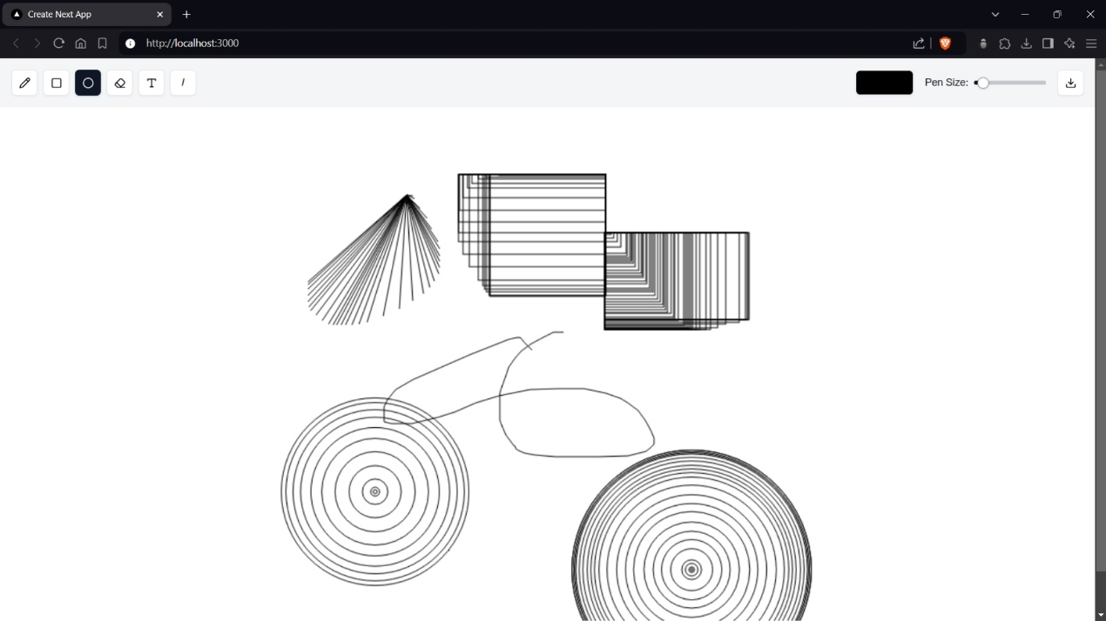  
  
  
  
  
  
  
  
  
  
Figure 8.1 Phase II of Online Paint

8.2 Code for Online Paint Phase II:

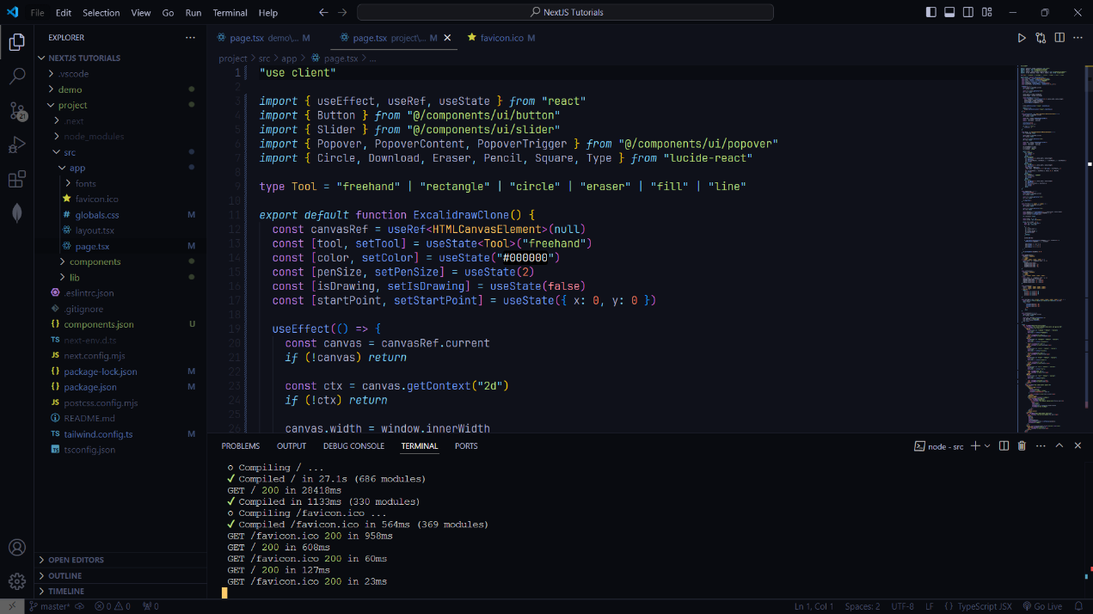

Figure 8.2 Code for Phase II of Online Paint

**Chapter 9  
Screenshots of Development Phase III**

9.1 Online Paint Phase III:

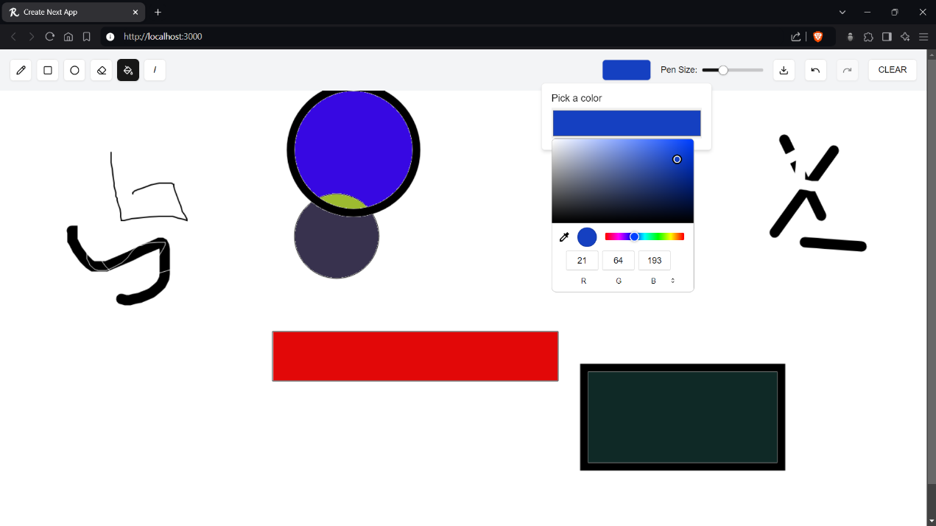  
  
  
  
  
  
  
  
  
  
Figure 9.1 Phase III of Online Paint

9.2 Code for Online Paint Phase III:

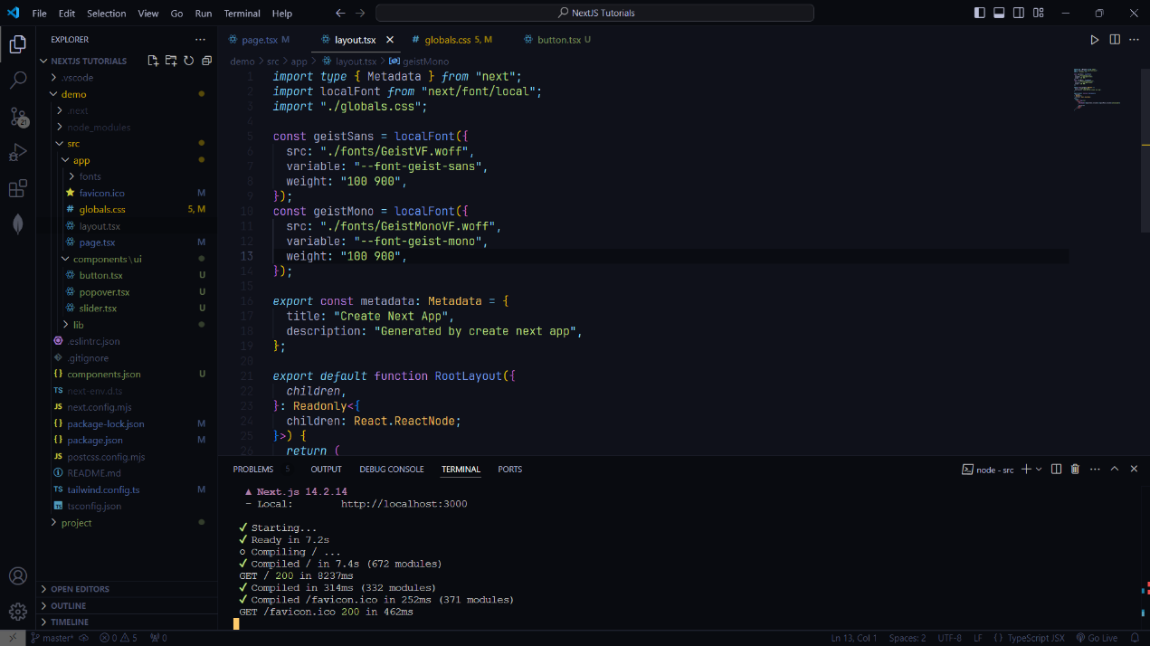

Figure 9.2 Code for Phase III of Online Paint

**Chapter 10  
Conclusion**

In conclusion, Online Paint successfully demonstrates the potential of web-based drawing applications, combining modern web technologies such as React and HTML5 Canvas to create a user-friendly and interactive platform. The application offers essential drawing tools and functionalities, enabling users to express their creativity through sketches, diagrams, and illustrations with ease.

The modular architecture and efficient state management ensure that the application is not only easy to use but also maintainable and adaptable for future enhancements. The ability to save creations and utilize various drawing tools makes Online Paint a valuable tool for both casual users and those seeking a digital canvas for more detailed artistic work.

As technology continues to evolve, there are ample opportunities for further development of Online Paint. Future iterations could include advanced features, such as collaborative drawing capabilities, additional drawing tools, and enhanced customization options, which would significantly enrich the user experience. Overall, Online Paint serves as a solid foundation for exploring the possibilities of online graphics applications and encouraging creativity in a digital space.

**Chapter 11  
Future Enhancements**

• **Custom Brushes and Textures:** Allow users to create custom brushes with textures.

• **Gradient Fills and Patterns:** Support gradient colour fills and patterns for shapes.

• **Real-Time Collaboration:** Enable multiple users to collaborate on the same canvas in real time.

• **Comments and Annotations:** Add comments or annotations to specific areas of the canvas.

• **Export in Multiple Formats:** Allow export in SVG, PDF, and PSD formats.

• **Basic Animation Tools:** Add tools to create simple frame-by-frame animations.

• **Cloud Storage Integration:** Integrate with Google Drive and Dropbox for file storage.

• **Dark Mode:** Provide a dark mode option for comfortable use in low-light environments.

• **Offline Mode:** Enable offline work with automatic sync when online.

• **Version Control:** Implement version control for easy rollback to previous drawings.

**Chapter 12  
References**

1. Microsoft Paint  
   <https://www.microsoft.com/en-us/windows/paint>
2. ExcalliDraw Clone  
   <https://github.com/mirayatech/NinjaSketch>
3. ChatGPT  
   <https://chatgpt.com>  
   <https://chat.openai.com>
4. Skribbl Multiplayer Drawing Game  
   <https://skribbl.io/>